DDS Board Design

AD9912

**- JJH -**

[jhjeong32@snu.ac.kr](mailto:jhjeong32@snu.ac.kr)

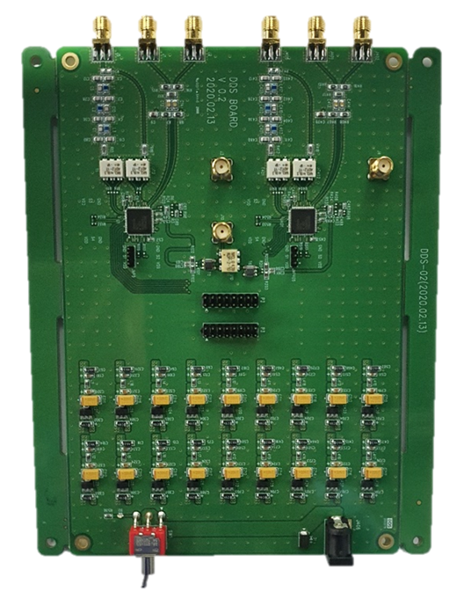

# Contents

**Contents** **2**

**Background** **4**

DDS Manual 4

Model 4

Specification 4

Basic Diagram 4

Pin configuration and function descriptions 5

Input/Output termination recommendations 7

Theory of Operation 8

Power-Up 11

Serial Control Port 13

Operation of Serial Control Port 13

Instruction Word (16 bits) 15

I/O Register Map 16

Evaluation Board 19

Model 19

Specification 20

Power connections 20

Reconstruction filter 20

PCB Manufacture 22

Terminology 22

Process 23

**Theory** **24**

Reference 24

DDS (Direct Digital Synthesis) 25

PLL (Phase Locked Loop) 27

**Design** **28**

PCB Board 28

Circuit 31

FPGA code 33

Python code 34

**Log** **35**

YYYY.MM.DD 36

2020.01.06 37

2020.01.08 40

2020.01.09 41

2020.01.10 42

2020.02.06 44

2020.02.07 47

# Background

## **DDS Manual**

### Model

* + - AD9912
    - 1 GSPS(Gigasample per second) Direct Digital Synthesizer with 14-Bit DAC

### Specification

* + - 1 GSPS internal clock speed (up to 400 MHz output directly)
    - 48-bit frequency tuning word with 4 μHz resolution
    - Differential HSTL comparator
    - On-chip low noise PLL REFCLK multiplier
    - Low jitter clock doubler for frequencies up to 750 MHz
    - Single-ended CMOS comparator; frequencies of < 150 MHz
    - Residual phase noise @ 250 MHz
      * 10 Hz offset: −113 dBc/Hz
      * 1 kHz offset: −133 dBc/Hz
      * 100 kHz offset: −153 dBc/Hz
      * 40 MHz offset: −161 dBc/Hz

### Basic Diagram

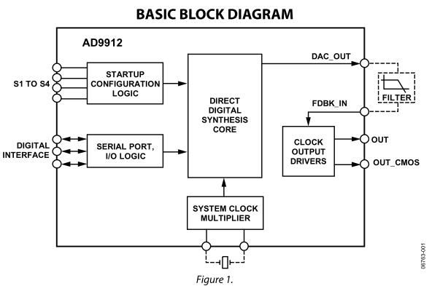

### Pin configuration and function descriptions

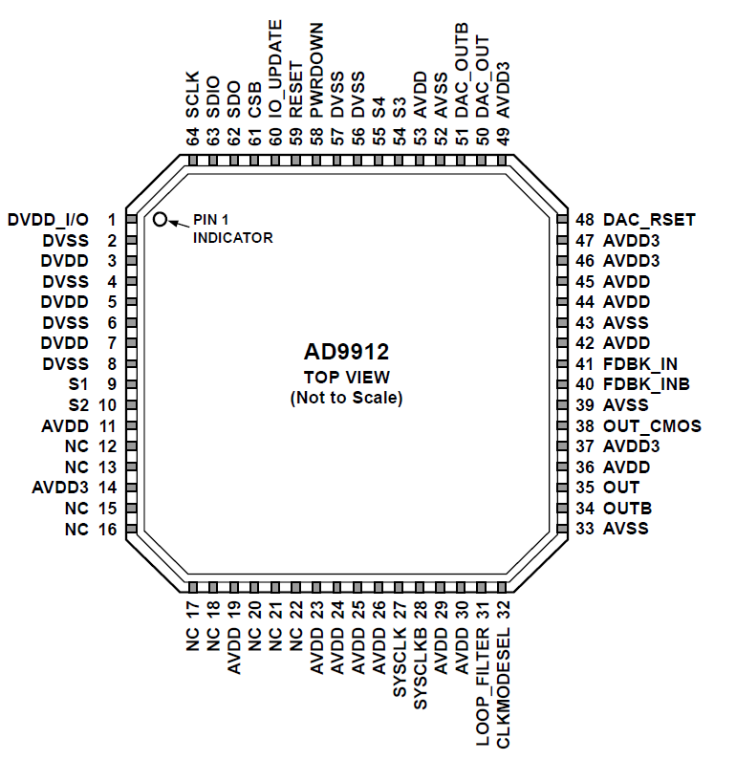

|  |  |  |  |  |
| --- | --- | --- | --- | --- |
| **Pin No.** | **I/O** | **Pin Type** | **Mnemonic** | **Description** |
| 1 | I | Power | DVDD_I/O | I/O Digital Supply |
| 2,4,6,8 | I | Power | DVSS | Digital Ground. Connect to ground |
| 3,5,7 | I | Power | DVDD | Digital Supply |
| 9,10,54,55 | I/O | 3.3V CMOS | S1,S2,S3,S4 | Start-Up Configuration Pins.  No pull-up/pull-down resistors |
| 11,19,23-26, 29,30,36,42,44,45,53 | I | Power | AVDD | Analog Supply  Connect to a nominal 1.8V supply |
| 12,13,15,16,17,18,20,21,22 |  |  | NC | No connect.  Can be left unconnected |
| 14,46,47,49 | I | Power | AVDD3 | Analog Supply  Connect to a nominal 3.3V supply |
| 27 | I | Differential input | SYSCLK | System clock input.  Should always be ac-coupled, except when using a crystal.  Single-ended 1.8V CMOS can also be used, but it may introduce a spur caused by an input duty cycle that is not 50%.  When using a crystal, tie the CLKMODESEL pin to AVSS, and connect crystal directly to this pin and Pin 28 |
| 28 | I | Differential input | SYSCLKB | Complementary system clock. Complementary signal to the input provided on Pin 27. Use a 0.01 μF capacitor to ground on this pin if the signal on Pin 27 is single-ended |
| 31 | O |  | LOOP_FILTER | System Clock Multiplier Loop Filter. When using the frequency multiplier to drive the system clock, an external loop filter must be constructed and attached to this pin. This pin should be pulled down to ground with 1 kΩ resistor when the system clock PLL is bypassed. See Figure 46 for a diagram of the system clock PLL loop filter. |
| 32 | I | 1.8 V CMOS | CLKMODESEL | Clock Mode Select. Set to GND when connecting a crystal to the system clock input (Pin 27 and Pin 28). Pull up to 1.8 V when using either an oscillator or an external clock source. This pin can be left unconnected when the system clock PLL is bypassed. |
| 33,39,43,52 | O | GND | AVSS | Analog Ground. Connect to ground |
| 34 | O | 1.8 V HSTL | OUTB | Complementary HSTL Output. |
| 35 | O | 1.8 V HSTL | OUT | HSTL Output. |
| 37 | I | Power | AVDD3 | Analog Supply for CMOS Output Driver. This pin is normally 3.3 V but can be 18 V. This pin should be powered even if the CMOS driver is not used. |
| 38 | O | 3.3 V CMOS | OUT_CMOS | CMOS single-ended Output. frequencies up to 150 MHz. |
| 40 | I | Differential input | FDBK_INB | Complementary Feedback Input. When using the HSTL and CMOS outputs, this pin is connected to the filtered DAC_OUTB output. This internally biased input is typically ac-coupled, and when configured as such, can accept any differential signal whose single-ended swing is at least 400 mV. |
| 41 | I | Differential input | FDBK_IN | Feedback Input. In standard operating mode, this pin is connected to the filtered DAC_OUT output. |
| 48 | O | Current set resistor | DAC_RSET | DAC Output Current Setting Resistor. Connect a resistor (usually 10 kΩ) from this pin to GND. |
| 50 | O | Differential output | DAC_OUT | DAC Output. This signal should be filtered and sent back on-chip through the FDBK_IN input. This pin has an internal 50 Ω pull-down resistor. |
| 51 | O | Differential output | DAC_OUTB | Complementary DAC Output. This signal should be filtered and sent back on-chip through the FDBK_INB input. This pin has an internal 50 Ω pull-down resistor. |
| 56,57 |  | Power | DVSS | Digital Ground. Connect to ground |
| 58 | I | 3.3 V CMOS | PWRDOWN | Power-Down. When this active high pin is asserted, the device becomes inactive and enters the full power-down state. This pin has an internal 50 kΩ pull-down resistor. |
| 59 | I | 3.3 V CMOS | RESET | Chip Reset. When this active high pin is asserted, the chip goes into reset. Note that on power-up, a 10 μs reset pulse is internally generated when the power supplies reach a threshold and stabilize. This pin should be grounded with a 10 kΩ resistor if not used. |
| 60 | I | 3.3 V CMOS | IO_UPDATE | I/O Update. A logic transition from 0 to 1 on this pin transfers data from the I/O port registers to the control registers (see the Write section). This pin has an internal 50 kΩ pull-down resistor. |
| 61 | I | 3.3 V CMOS | CSB | Chip Select. Active low. When programming a device, this pin must be held low. In systems where more than one AD9912 is present, this pin enables individual programming of each AD9912. This pin has an internal 100 kΩ pull-up resistor. |
| 62 | O | 3.3 V CMOS | SDO | Serial Data Output. When the device is in 3-wire mode, data is read on this pin. There is no internal pull-up/pull-down resistor on this pin. |
| 63 | I/O | 3.3 V CMOS | SDIO | Serial Data Input/Output. When the device is in 3-wire mode, data is written via this pin. In 2-wire mode, data reads and writes both occur on this pin. There is no internal pull-up/pull-down resistor on this pin. |
| 64 | I | 3.3 V CMOS | SCLK | Serial Programming Clock. Data clock for serial programming. This pin has an internal 50 kΩ pull-down resistor. |
| Exposed Die Pad | O | GND | GND | Analog Ground. The exposed die pad on the bottom of the package provides the analog ground for the part; this exposed pad must be connected to ground for proper operation. |

### Input/Output termination recommendations

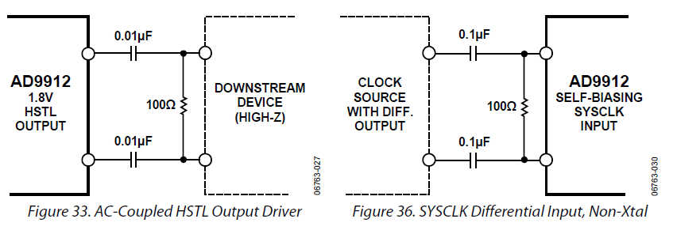

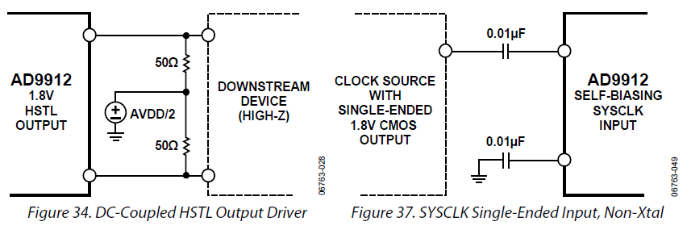

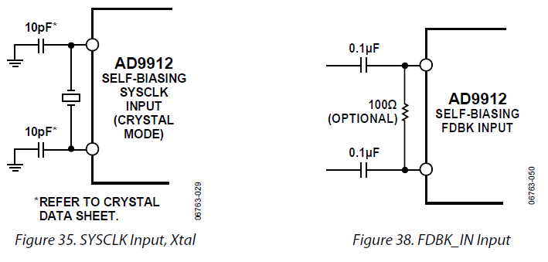

### Theory of Operation

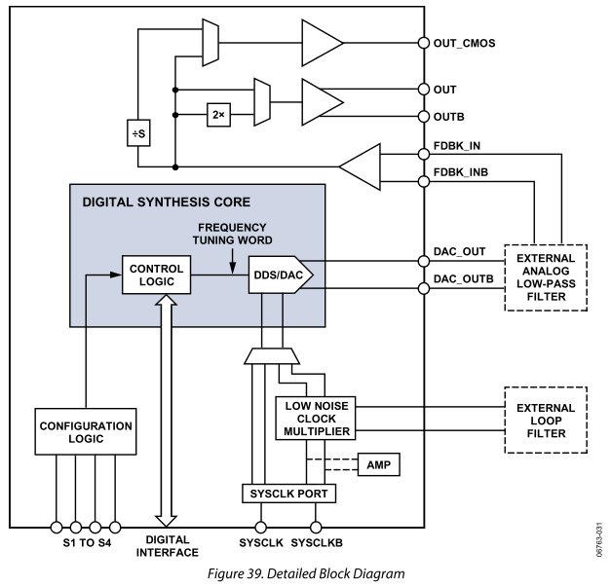

* + - Direct Digital Synthesizer
      * The frequency of the sinusoid generated by the DDS
        + Determined by a frequency tuning word (FTW), which is a digital value
      * DDS uses digital building blocks and operates as a sampled system
        + It requires a sampling clock (*fs*) that serves as the fundamental timing source of the DDS
        + The accumulator behaves as a modulo-248 counter with a programmable step size that is determined by FTW
      * A block diagram of DDS is

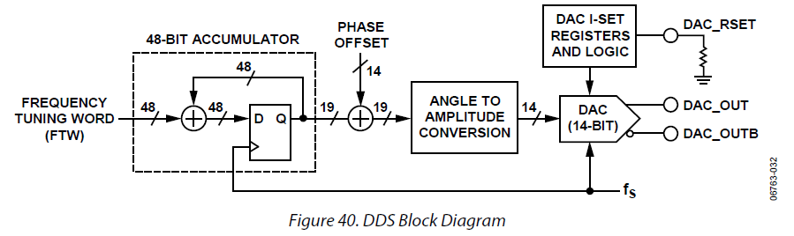

* + - * The input to the DDS is a 48-bit FTW that provides the accumulator with a seed value
        + On each cycle of *fs*, the accumulator adds the value of the FTW to the running total of its output
        + Over time, the accumulator reaches the upper end of its capacity (248 in this case)
        + And then rolls over, retaining the excess
      * The average rollover rate of the accumulator and establishes the output frequency (*fDDS*) of the DDS

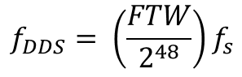

* + - * Solving this equation for FTW yields

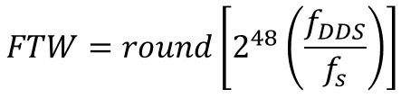

* + - * The relative phase of the sinusoid can be controlled numerically as well
        + By using the phase offset function of the DDS

A programmable 14-bit value

* + - * + *ΔΦ* (radians) is given by

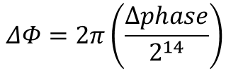

* + - FDBK_In Inputs
      * Serve as the input to the comparators and output drivers of the AD9912
      * These pins are used to receive the signal generated by the DDS after its has been filtered out
      * Input pins are internally biased to a dc level of ~ 1 V
      * Make sure any external connections do not disturb the dc bias
        + May significantly degrade performance

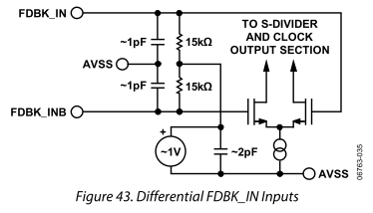

* + - SYSCLK inputs
      * Generates the internal high frequency system clock (*fs*)
      * It can be operated in one of the following three modes
        + SYSCLK PLL bypassed
        + SYSCLK PLL enabled with input signal generated externally
        + Crystal resonator with SYSCLK PLL enabled
      * The SYSCLK PLL multiplier
        + Enabled by a Logic 0 (default) in the PD SYSCLK PLL bit (Register 0x0010, Bit 4) of the I/O register map
        + Can be driven from the SYSCLK input pins depending on the logic level CMOS CLKMODESEL pin

0: A crystal can be connected across the SYSCLK pins

1: An external frequency source can be connected to the SYSCLK input pins

The system clock PLL is not disabled

* + - * + When the SYSCLK PLL multiplier path is disabled, the AD9912 must be driven by a high frequency signal source (250 MHz to 1 GHz).

The signal thus applied to the SYSCLK input pins becomes the internal DAC sampling clock (*fS*) after passing through an internal buffer.

* + - * + It is important to note that when bypassing the system clock PLL, the LOOP_FILTER pin (Pin 31) should be pulled down to the analog ground with a 1 kΩ resistor.

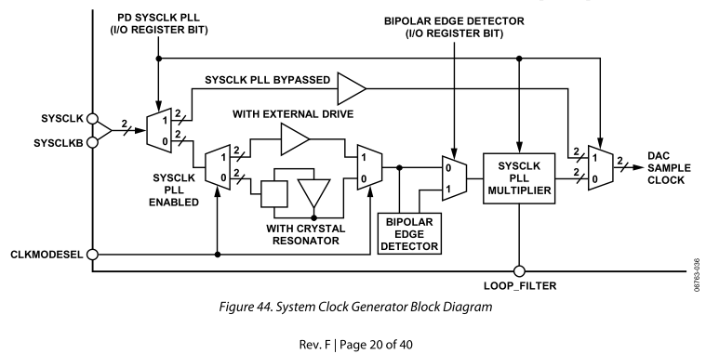

* + - SYSCLK PLL Doubler
      * SYSCLK PLL multiplier path offer an optional **SYSCLK PLL doubler**
        + By generating a pulse on each edge of the SYSCLK input signal (nyquist frequency)
      * The main drawback
        + The doubler output is not a rectangular pulse with a constant duty cycle

Even for a symmetric SYSCLK input signal

* + - * Note that generally, the benefits of the SYSCLK PLL doubler
        + Realized for SYSCLK input frequencies of 25 MHz and above
    - Primary 1.8 V Differential HSTL Driver
      * This DDS output signal is routed off chip
        + Where it is passed through an analog filter and brought back on chip for buffering
        + If necessary, frequency doubling
      * The HSTL output should be ac-coupled
        + With 100 Ω termination at the destination
        + The driver design has low jitter injection for frequencies in the range of 50 MHz to 750 MHz

### Power-Up

* + - Power-On Reset
      * On initial power-up, it generates a 75 ns RESET pulse
      * The condition:
        + 3.3 V supply is greater than 2.35 V ± 0.1 V
        + 1.8 V supply is greater than 1.4 V ± 0.05 V
      * The S1 to S4 config pins go high impedance and remain high
        + Until RESET is deactivated
    - Default Output Frequency on Power-Up
      * At power-up, internal logic initiates a reset pulse of about 10 ns
        + During this time, S1 to S4 briefly function as input pins
        + Any logic levels thus applied are transferred to a 4-bit register on the falling edge of the internally initiated.
      * For default startup, 16 states are possible by
        + 8 x 16 ROM which contains eight 16-bit DDS frequency tuning words (FTWs)
        + SYSCLK mode
      * The selected FTW is transferred to the FTW0 register in the I/O register map
        + This ensures that the DDS generates the selected frequency even if the I/O registers have not been programmed
      * The S4 pin whether the internal system clock is generated
        + By means of the internal SYSCLK PLL multiplier or not

**Table 8. Default Power-Up Frequency Options for 1 GHz System Clock**

|  |  |  |  |  |  |
| --- | --- | --- | --- | --- | --- |
| **Status Pin** | | | | **SYSCLK**  **Input Mode** | **Output Frequency**  **(MHz)** |
| **S4** | **S3** | **S2** | **S1** |
| 0 | 0 | 0 | 0 | Xtal/PLL | 0 |
| 0 | 0 | 0 | 1 | Xtal/PLL | 38.87939 |
| 0 | 0 | 1 | 0 | Xtal/PLL | 51.83411 |
| 0 | 0 | 1 | 1 | Xtal/PLL | 61.43188 |
| 0 | 1 | 0 | 0 | Xtal/PLL | 77.75879 |
| 0 | 1 | 0 | 1 | Xtal/PLL | 92.14783 |
| 0 | 1 | 1 | 0 | Xtal/PLL | 122.87903 |
| 0 | 1 | 1 | 1 | Xtal/PLL | 155.51758 |
| 1 | 0 | 0 | 0 | Direct | 0 |
| 1 | 0 | 0 | 1 | Direct | 38.87939 |
| 1 | 0 | 1 | 0 | Direct | 51.83411 |
| 1 | 0 | 1 | 1 | Direct | 61.43188 |
| 1 | 1 | 0 | 0 | Direct | 77.75879 |
| 1 | 1 | 0 | 1 | Direct | 92.14783 |
| 1 | 1 | 1 | 0 | Direct | 122.87903 |
| 1 | 1 | 1 | 1 | Direct | 155.51758 |

### 

### Serial Control Port

* + - Serial Control Port Pin Descriptions
      * SCLK (serial clock)
        + Serial shift clock, an input
        + To synchronize serial control port reads and writes
        + This pin has an internal pull-down resistor
      * SDIO (serial data input/output)
        + Dual-purpose pin, input only or input/output
        + SDIO can be used as a unidirectional I/O pin by writing to the SDO active bit (Register 0x0000, Bit 0 = 1)

SDIO is the input, SDO is the output

* + - * CSB (chip select bar)
        + Active low control that gates the read and write cycles
        + When CSB is high

SDO and SDIO are in a high impedance state

* + - * + Internally pulled up by a 100 kΩ resistor to 3.3 V
        + It should not be left floating

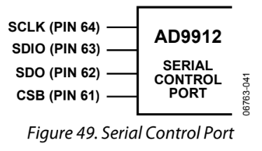

### Operation of Serial Control Port

* + - Framing a Communication Cycle with CSB
      * A write or a read operation is gated by the CSB line
      * CSB must be brought low to initiate a communication cycle
      * CSB stall high is supported in modes
        + Where three or fewer bytes of data are transferred ([W1:W0], mubt be set to 00, 01 or 10)

CSB can temporarily return high on any byte boundary, allowing time for the system controller to process the next byte

* + - * + CSB can go high on byte boundaries only and can go high during either part (instruction or data) of the transfer

How to abort transfer: the state machine must be reset by completing the remaining transfer or by returning the CSB low for at least one SCLK cycle (but fewer than 8 SCLK cycles)

* + - * In the streaming mode ([W1:W0] = 11)
        + any number of data can be transferred in a stream
        + CSB must be raised at the end of the last byte to be transferred (end of the stream mode)

**Table 9. Byte Transfer Count**

|  |  |  |
| --- | --- | --- |
| **W1** | **W0** | **Bytes to Transfer**  **(Excluding the 2-Byte Instruction)** |
| **0** | **0** | **1** |
| **0** | **1** | **2** |
| **1** | **0** | **3** |
| **1** | **1** | **Streaming mode** |

* + - WRITE
      * In write operation (*I15 = 0*)
        + The length of the transfer is indicated by two bits ([W1:W0])
        + CSB can be raised after each sequence of eight bits to stall the bus

When the bus is stalled, the serial transfer resumes when CSB is lowered

* + - * Three types of registers on the AD9912  
        - Buffered  
        - Live  
        - Read-only
        + Buffered

Requires I/O update to transfer

Toggling IO_UPDATE pin or writing a 1 to the register update bit  
(Register 0x0005, Bit 0)

The update simultaneously enables all register changes that have occurred since any previous update

Marked with an M

* + - * + Live

No requirement of I/O update

Update immediately after being written

* + - * + Read-only

Ignores write commands

Marked with RO

* + - * AC in this column indicates that the register is autoclearing.

### 

### Instruction Word (16 bits)

* + - The MSB of the instruction word is R/~W
      * The first 2 bits [W1:W0] are the transfer length in bytes
      * The final 13 bits are the address [A12:A0]
        + Where to begin the read or write operation

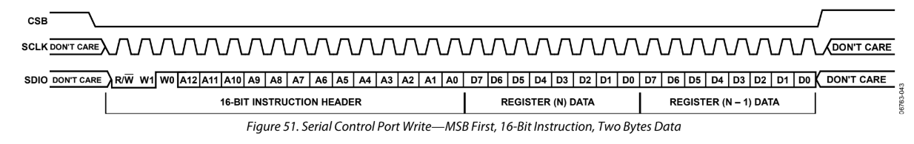

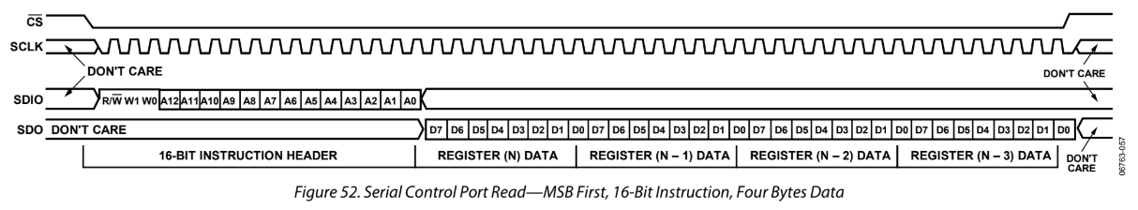

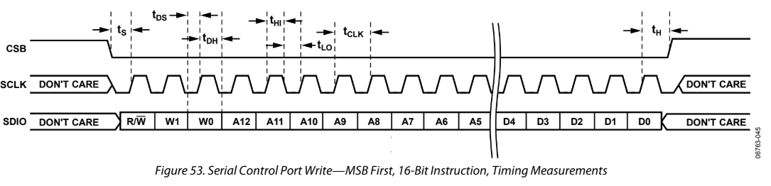

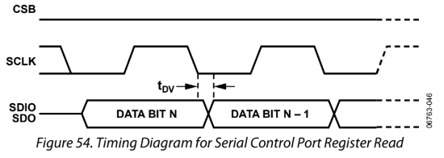

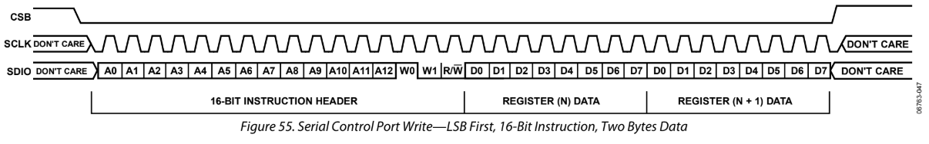

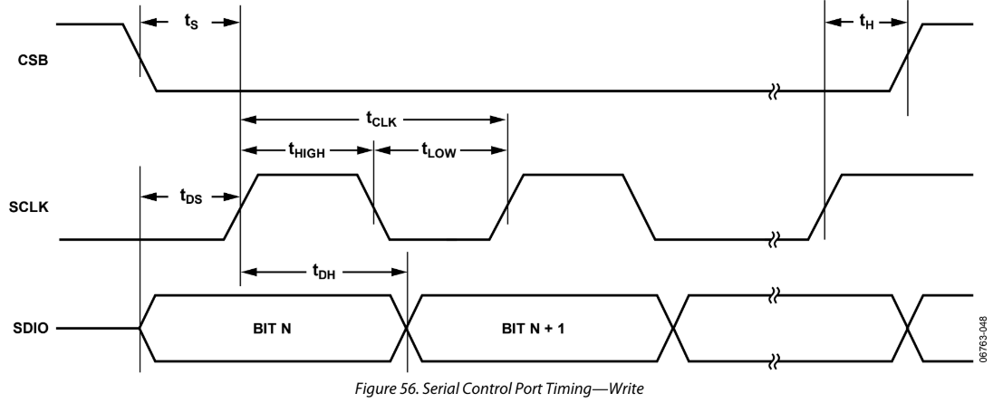

**Table 11. Definitions of Terms Used in Serial Control Port Timing Diagram**

|  |  |
| --- | --- |
| **Parameter** | **Description** |
| **tCLK** | Period of SCLK |
| **tDV** | Read data valid time (From falling edge of SCLK to valid data on SDIO/SDO) |
| **tDS** | Setup time between data and rising edge of SCLK |
| **tDH** | Hold time between data and rising edge of SCLK |
| **tS** | Setup time between CSB and SCLK |
| **tH** | Hold time between CSB and SCLK |
| **tHI** | Minimum period that SCLK should be in a logic high state |
| **tLO** | Minimum period that SCLK should be in a logic low state |

### I/O Register Map

**Table 12.**

|  |  |  |  |  |  |  |  |  |  |  |  |
| --- | --- | --- | --- | --- | --- | --- | --- | --- | --- | --- | --- |
| **Addr**  **(Hex)** | **Type** | **Name** | **Bit 7** | **Bit 6** | **Bit 5** | **Bit 4** | **Bit 3** | **Bit 2** | **Bit 1** | **Bit 0** | **Default**  **(Hex)** |
| Serial port configuration and part identification | | | | | | | | | | | |
| 0x0000 |  | Serial config. | SDO active | LSB first  (buffered) | Soft reset | Long instruction | Long instruction | Soft reset | LSB first  (buffred) | SDO active | 0x18 |
| 0x0001 |  | Reserved |  |  |  |  |  |  |  |  | 0x00 |
| 0x0002 | RO | Part ID | Part ID | | | | | | | | 0x02 |
| 0x0003 | RO | 0x19 |
| 0x0004 |  | Serial options |  |  |  |  |  |  |  | Read buffer register | 0x00 |
| 0x0005 | AC |  |  |  |  |  |  |  | Register update | 0x00 |
| Power-down and reset | | | | | | | | | | | |
| 0x0010 |  | Power-down and enable | PD HSTL driver | Enable CMOS driver | Enable output doubler | PD SYSCLK PLL |  |  | Full PD | Digital PD | 0xC0 or 0xD0 |
| 0x0011 |  | Reserved |  |  |  |  |  |  |  |  | 0x00 |
| 0x0012 | M, AC | Reset |  |  |  |  |  |  |  | DDS reset | 0x00 |
| 0x0013 | M | PD fund DDS |  |  |  | S-div/2 reset |  | S-divider reset |  | 0x00 |
| System clock | | | | | | | | | | | |
| 0x0020 |  | N-divider |  |  |  | N-divider, Bits[4:0] | | | | | 0x12 |
| 0x0021 |  | Reserved |  | | | | | | | | 0x00 |
| 0x0022 |  | PLL parameter | VCO auto range |  |  |  | 2x reference | VCO range | Charge pump current Bits[1:0] | | 0x04 |
| CMOS output divider (S-divider) | | | | | | | | | | | |
| 0x0100 |  | Reserved |  | | | | | | | | 0x30 |
| 0x0101 to 0x0103 |  | Reserved |  | | | | | | | | 0x00 |
| 0x0104 and 0x0105 |  | S-divider | S-divider, Bits[15:0]  LSB: Register 0x0104 | | | | | | | | 0x00 |
| 0x0106 |  | Falling edge triggered |  |  |  |  |  |  | S-divider/2 | 0x01 |
| Frequency tuning word | | | | | | | | | | | |
| 0x01A0 to 0x01A5 |  | Reserved |  | | | | | | | | 0x00 |
| 0x01A6 | M | FTW0 (frequency tuning word) | FTW0, Bits[47:0]  LSB: Register 0x01A6 | | | | | | | | 0x00 |
| 0x01A7 | M | 0x00 |
| 0x01A8 | M | 0x00 |
| 0x01A9 | M | 0x00 |
| 0x01AA | M | Start-up cond. |
| 0x01AB | M | Start-up cond. |
| 0x01AC | M | Phase | DDS phase word, Bits[7:0] | | | | | | | | 0x00 |
| 0x01AD | M |  |  | DDS phase word, Bits[13:8] | | | | | | 0x00 |
| Doubler and output drivers | | | | | | | | | | | |
| 0x0200 |  | HSTL driver |  |  |  | OPOL (polarity) |  |  | HSTL output doubler, Bits[1:0] | | 0x05 |
| 0x0201 |  | CMOS driver |  |  |  |  |  |  |  | CMOS mux | 0x00 |
| Calibration (user-accessible trim) | | | | | | | | | | | |
| 0x0400 to 0x040A |  | Reserved |  |  |  |  |  |  |  |  | 0x00 |
| 0x040B |  | DAC full-scale current | DAC full-scale current, Bits[7:0] | | | | | | | | 0xFF |
| 0x040C |  |  |  |  |  |  |  | DAC full-scale current  Bits[9:8] | | 0x01 |
| 0x040D |  | Reserved |  | | | | | | | | 0x00 |
| 0x040E |  | Reserved |  | | | | | | | | 0x10 |
| 0x040F and 0x0410 |  | Reserved |  | | | | | | | | 0x00 |
| Harmonic spur reduction | | | | | | | | | | | |
| 0x0500 | M | Spur A | HSR-A enable | Amplitude gain x 2 |  |  |  | Spur A harmonic, Bits[3:0] | | | 0x00 |
| 0x0501 | M | Spur A magnitude, Bits[7:0] | | | | | | | | 0x00 |
| 0x0503 | M | Spur A phase, Bits[7:0] | | | | | | | | 0x00 |
| 0x0504 | M |  |  |  |  |  |  |  | Spur A phase, Bit 8 | 0x00 |
| 0x0505 | M | Spur B | HSR-B enable | Amplitude gain x 2 |  |  | Spur B harmonic, Bits[3:0] | | | | 0x00 |
| 0x0506 | M | Spur B magnitude, Bits[7:0] | | | | | | | | 0x00 |
| 0x0508 | M | Spur B phase, Bits[7:0] | | | | | | | | 0x00 |
| 0x0509 | M |  |  |  |  |  |  |  | Spur B phase,Bit 8 | 0x00 |

## 

## **Evaluation Board**

### Model

* + - EVAL-AD9912A/PCBZ

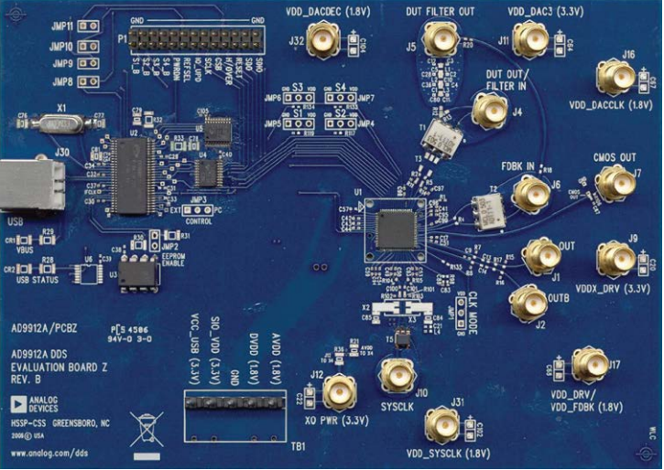

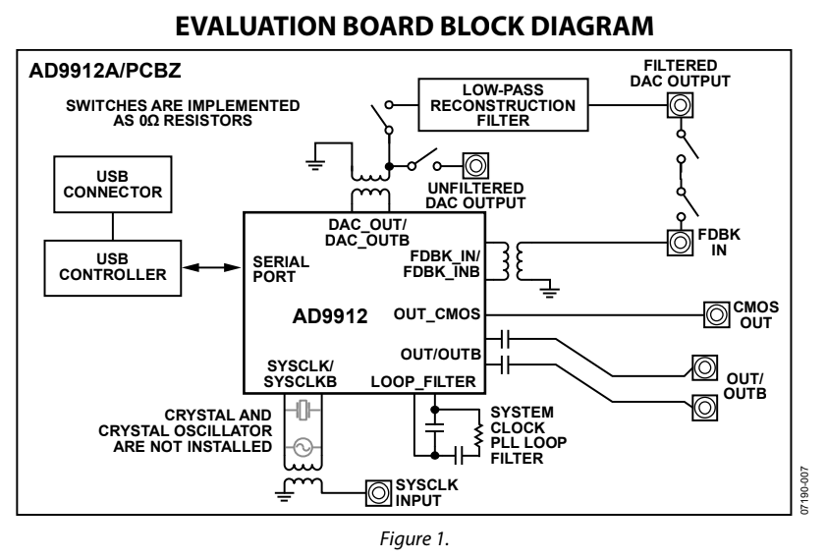

### Specification

* + - Output frequency: 155.52 MHz
    - DAC system clock: 1,000 MHz
      * Provided on the SYSCLK SMA connector
    - System clock PLL is disabled

### Power connections

* + - Connect power and ground to the main power connector labeled TB1
    - Connect a 1.8 V supply to VDD_DACDEC (J32)
    - Connect a 3.3 V supply to the following AD9912 SMA connectors: VDD_DAC3 (J11) and XO_PWR (J12)  
      **(XO_PWR is only necessary if there is a crystal oscillator mounted on the board)**
    - If using the CMOS OUT (J7), power must be applied to VDDX_DRV (J9) and R106 must be populated with 0 Ω resistor.
      * VDDX_DRV can be either 1.8 V or 3.3 V
      * The power-on default of the AD9912 is **CMOS driver enabled, HSTL driver disabled**
    - Ensure that the S1 to S4 jumpers are tied to VDD.
      * These settings are only for generating 155.52 MHz at startup and register programming overrides these settings

### Reconstruction filter

* + - The eval board has a 240 MHz low-pass reconstruction filter
    - Implemented as a single-ended filter with a transformer on both sides
      * To convert to/from a differential configuration
    - -3 dB bandwidth is approximately 0.3 MHz to 300 MHz
    - Single-Ended filter design
      * Recommended for cases where the cutoff frequency must be tightly controlled
    - 7th order single-ended low-pass elliptical filter
      * Pass-band frequency: 240 MHz
      * Pass-band ripple: 0.1 dB
      * Stop-band ratio: 1.3
      * Stop-band frequency: 312 MHz
      * Stop-band attenuation: 60 dB

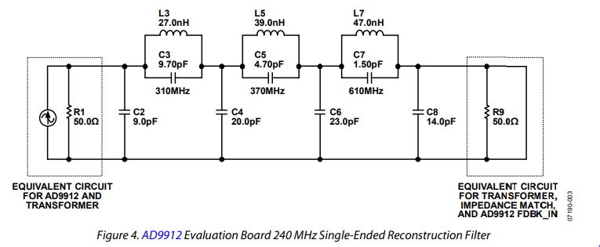

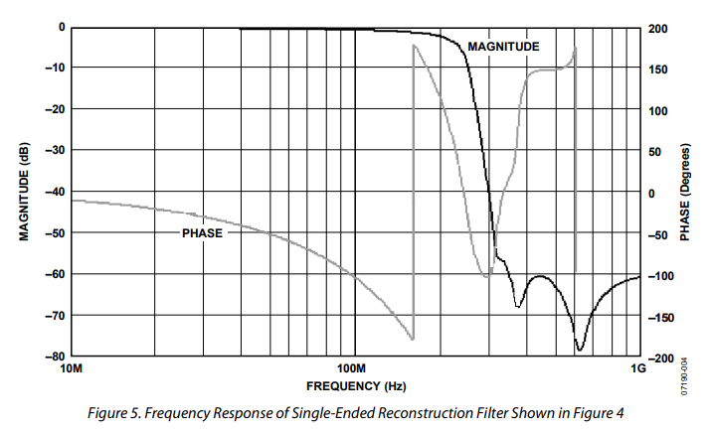

## PCB Manufacture

### Terminology

* + - SMT (Surface Mount Technology)
      * A method where the components are mounted or placed directly onto the surface of a PCB
      * Instead of THT(T[hrough-hole technology](https://en.wikipedia.org/wiki/Through-hole_technology)) construction method
        + Which is fitting components with wire leads into holes in the circuit board
    - Electroless Plating
      * Also known as 무전해도금
      * Used to plate holes to make PTHs and vias
        + It finishes the fabrication process
      * Materials
        + HASL (Hot Air Solder Levelling)

One of the easiest and popular methods

Flatten the solder with Pb/Sn

Not good for tiny patterns

* + - * + Gold Plating

무전해금도금

Suitable for high density patterns

Widely used but a bit expensive

* + - * + OSP (Organic Solderability Preservative)

Suitable for high density patterns

ECO-friendly

Mechanically fragile

* + - * + Immersion tin plating

무전해주석도금

ECO-friendly

Suitable for high density patterns

Handling with care, since the bare hands could oxidize it

* + - * + Immersion silver plating

Not widely used yet

* + - PTH (Plated Through Hole)
      * After drilling the boards a thin copper is placed onto the walls of the holes, providing them with electrical conductivity

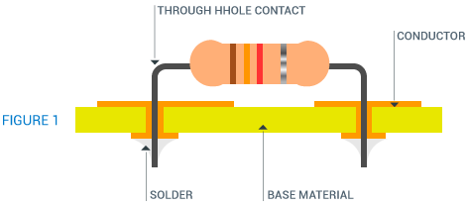

* + - Artwork
      * Designing of the pcb layout
        + With OrCad or Eagle or simply “Viewmate”
        + For example, where to put capacitors or how to connect the wires

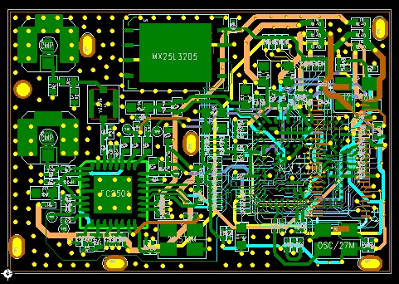

* + - * + Extra payment might be charged if you want to change the layers after is 1st job done.
        + It is charged per day. (~200$/day)
      * Silk
        + Printing on the surface of the PCB board.
        + Usually in order for the user to read the name of pins

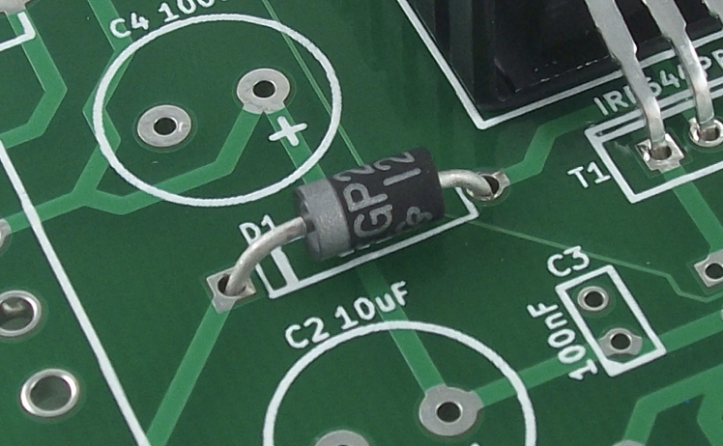

* + - BOM
      * Stands for Bill of Materials
      * It contains the information (specs and model names) of the components
        + To get a proper quote, you must send the BOM to the manufacturing company
        + Must contain all components that you want

if some components are out-of-date

Need to choose substitutes but check if the spec is the same

Or choose reasonable substitutes

* + - Layer Stackup
      * The arrangement of copper layers and insulating layers that make up a PCB prior to board layout design
      * Impedance calculation must be included
        + Standard Stackup @ EOSI as a reference

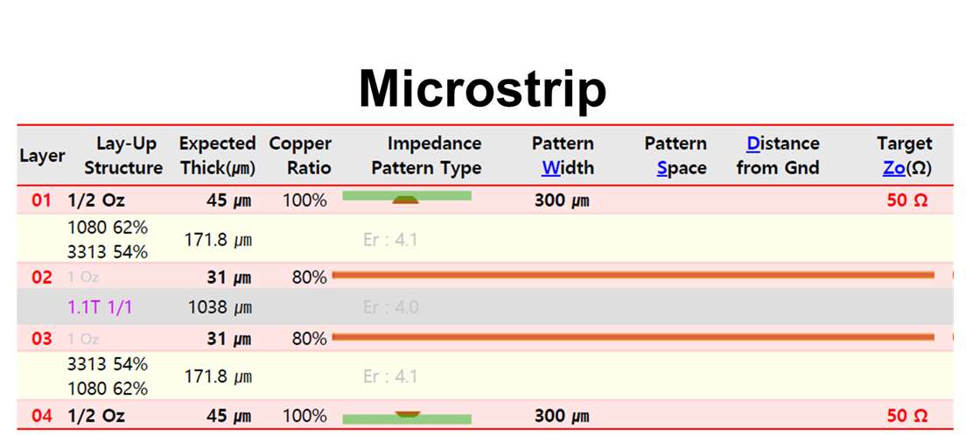

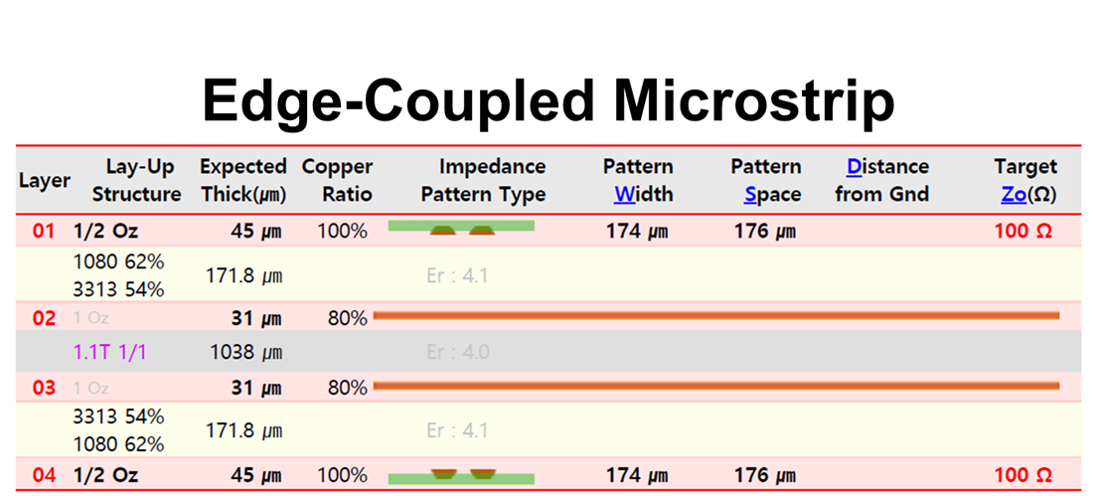

* + - * Materials
        + FR4 (for relatively low-freq.)
        + Rogers (for high-freq.)

A USA company which is a leading supplier of specialty materials

* + - * + When do we need Rogers?

When we want to generate an **ideal sine-wave**

While the square wave

It uses the combination of the harmonics to make the wave square

If the materials absorb the harmonics, for example, FR4, the harmonics are faded away

i.e. the square wave could be made

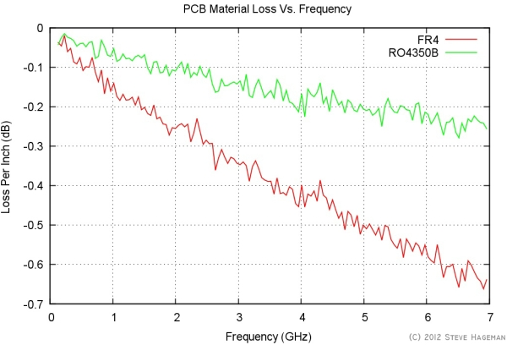

### Process

1. Check out the desired frequency

2. Circuit schematic

3. Choose the components suitable to the desired specs  
 3.1. Write a BOM and send it to the manufacturer  
 3.2. If some items are discontinued, find alternatives.

4. Request the standard stackup to the manufacturer

4.1. Calculate if the impedances are matched

4.2. Request stackup modification

5. Artwork

5.1. Inspect carefully if the connections are correct

### 

# Theory

## 

## **Reference**

* + Direct Digital Synthesis
    - Analog Devices AD9912 User Manual, *Analog Devices*, 2010.
    - Paul Kern (July 2007). "Direct digital synthesis enables digital PLLs" [(PDF)](https://drive.google.com/file/d/1IFn1tOFzfQulK9GZscALRpb8Tc8-3Wrh/view?usp=sharing). RFDesign.
  + Phase Locked Loop
    - A. H. Ahmed, “Introduction to Phase Locked Loop (PLL)”, DIGITAVID, inc. ([PDF](http://faculty.uml.edu/ahmed_abuhajar/documents/IntroductiontoPLL.pdf))
  + Equivalent Series Resistance
    - “Equivalent series resistance”, *Wikipedia*, <https://en.wikipedia.org/wiki/Equivalent_series_resistance>

## **DDS (Direct Digital Synthesis)**

* + Introduction
    - Direct Digital Synthesis(DDS) is a method employed by frequency synthesizers
    - Used for creating arbitrary waveforms from a single, fixed-frequency reference clock
    - Main usages are
      * Signal generation
      * Local oscillators
      * Function generators, mixers, modulators
  + Composition
    - Frequency reference
      * Crystal or Surface Acoustic Wave (SAW)
      * Provides the clock to the NCO
    - Numerically Controlled Oscillator (NCO)
      * Produces at its output a discrete-time, quantized version of the desired output waveform
        + Whose period is controlled by the digital word
    - Digital-to-Analog Converter (DAC)

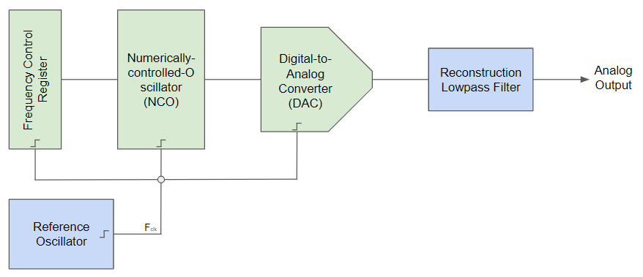

* + Performance
    - Advantages
      * Improved phase noise
      * Need only an external clock to generate simple sine waves
      * Precise control of the output phase across frequency switching transitions
    - Disadvantages
      * Spurious responses due to truncation effects in the NCO
      * Higher noise floor at large frequency offsets due to the DAC
  + How to make a sine wave

## **PLL (Phase Locked Loop)**

* + Introduction
    - An electronic module (Circuit) that locks the phase of the output to the input.

* + a
* a
* a

## **ESR (Equivalent Series Resistance)**

* + Introduction
    - Practical capacitors and inductors as used in electric circuits are not ideal components with only capacitance or inductance.
    - However, they can be treated as ideal capacitors and inductors in series with a resistance
    - This resistance is defined as the **equivalent series resistance** (**ESR**)
  + Component Models
    - If drive by a periodic sinewave
      * The component will be characterised by its complex impedance

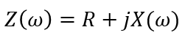

* + - * These small deviations from the ideal behavior of the device can become significant under certain conditions
        + Typically **high frequency**, where the reactance *X(ω)* of small capacitances and inductances can become a significant element of circuit operation
      * For many purposes
        + A simple model with an inductance or capacitance in series with an ESR is good enough.
  + Inductors
    - Inductors have resistance inherent in the metal conductor
      * Quoted as **DCR** in datasheets
    - This metallic resistance is small for small inductance value (typically below 1Ω)
    - It can be modeled as a resistor in series with the inductor
      * Often leading to the **DC resistance being referred to as the ESR**
    - An inductor using a core to increase inductance will have loss such as hysteresis and eddy current in the core.
    - At high frequency
      * Losses in the windings due to proximity and skin effects
      * Proximity
        + In a conductor carrying alternating current
        + If currents are flowing through one or more other nearby conductors, such as within a closely wound coil of wire,

The distribution of current within the first conductor will be constrained to smaller regions.

* + - * + The total resistance of a portion is given by

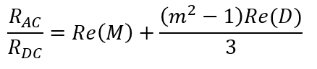

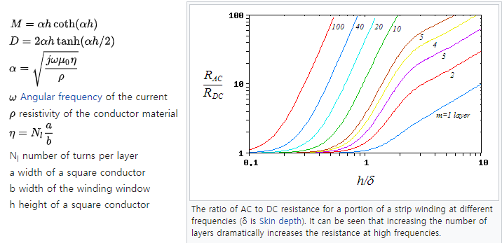

* + - * Skin effect

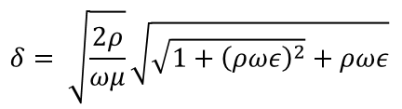

* + Capacitors
    - The metallic resistance of the leads and electrodes and losses in the dielectric cause the ESR.
    - Typically quoted values of ESR for ceramic capacitors are between 0.01 and 0.1 Ω.
    - For high frequency

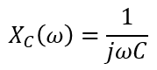

* + - * The reactance goes to zero, which leads the resistance of the capacitor is dominant

## **Microstrip**

* + Introduction
  + Online calculator
    - <http://www.rfdh.com/rfdb/msline.htm>

# Design

## PCB Board

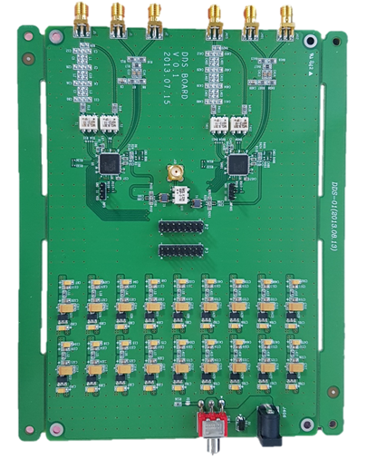

* + Reference input
    - Accepts a single-ended reference input as SYSCLK
    - Divided into 2 ports
      * Making them differential inputs artificially

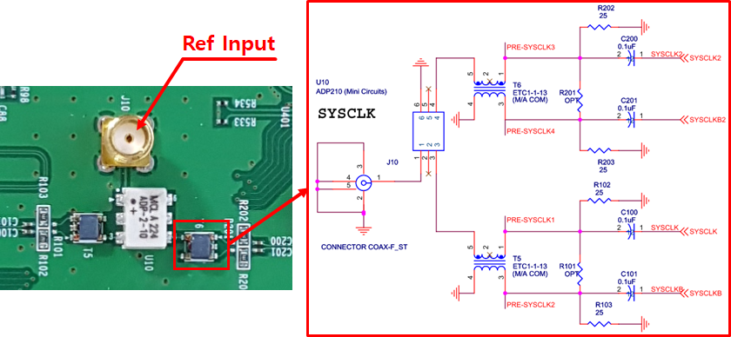

* + Power ports
    - Power ports from eval board are integrated onboard
    - No power ports are needed
      * Accepts a DC input only

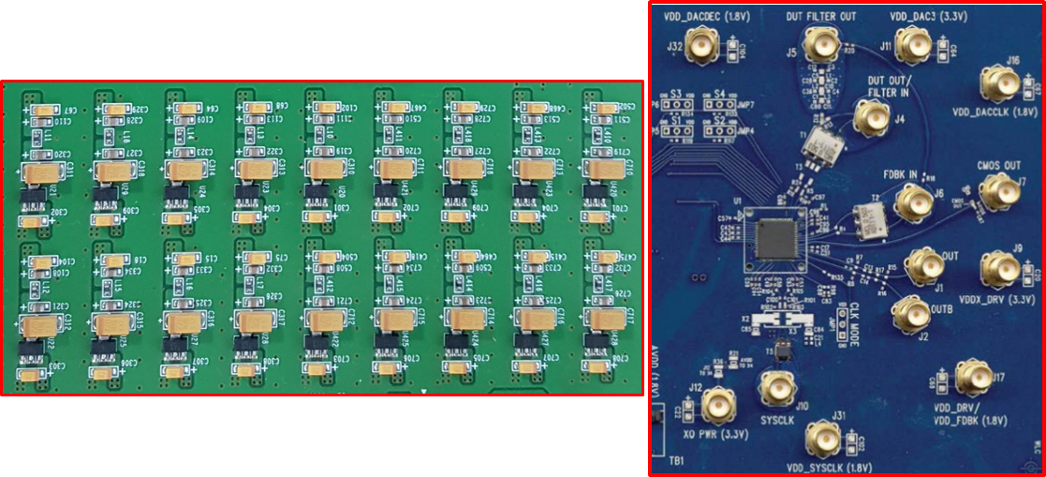

* + Output ports
    - DAC Output with low-pass filter
    - Differential Output

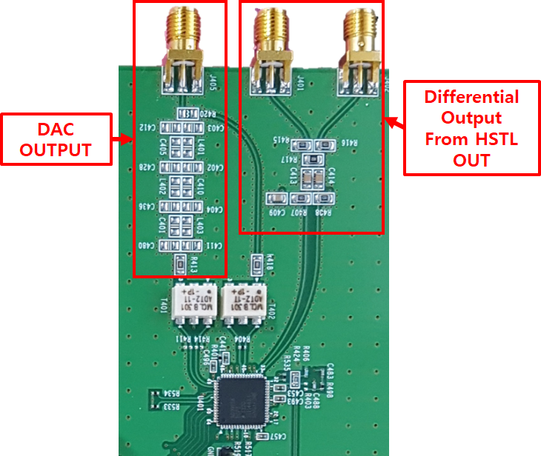

## 

## Circuit

* + Pins layout

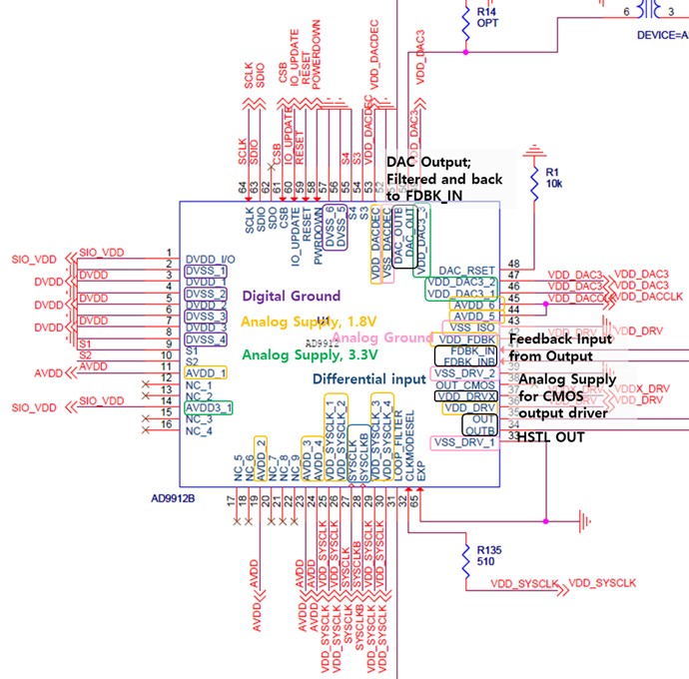

* + Start-up configuration pins
    - S2 to S4 pins are set to 1
    - Only S1 is used to read and write

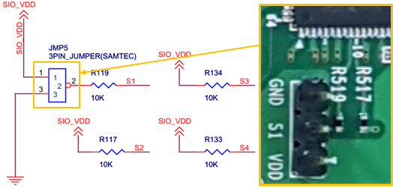

* + General input pins
    - P2 and P3 pins accept general inputs to operate normally
    - P3 pins use IO_UPDATE pins only

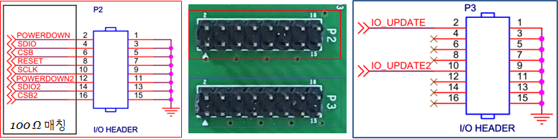

## 

## FPGA code

* + Interface
  + Block Diagram

## Python code

# Log

### YYYY.MM.DD

* Goal
* Progress
* To do

### 2020.01.06

* **Goal**
  + Understand DDS circuit
* **Progress**
  + Pins



* + - LOOP_FILTER

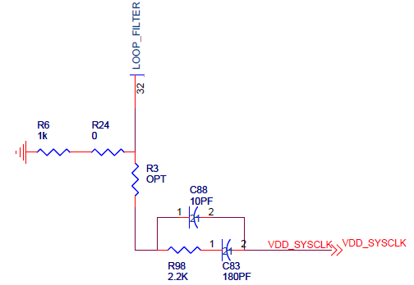

* + - * System Clock Multiplier Loop Filter (Connected with Optional Resistor)
        + When using the frequency multiplier to drive the system clock, **an external loop filter must be constructed and attached to this pin**.
        + This pin should be pulled down to ground with 1 kΩ resistor when the system clock PLL is bypassed
    - CLKMODESEL

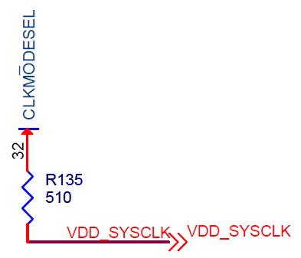

* + - * Pull up to 1.8 V when using **either an oscillator or an external clock source**. This pin can be left unconnected when the system clock PLL is bypassed.
    - DAC_RSET

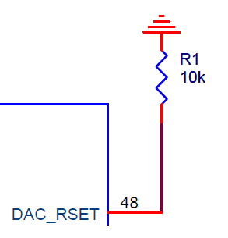

* + - * DAC Output Current Setting Resistor. Connect a resistor (usually 10 kΩ) from this pin to GND.
    - SDO

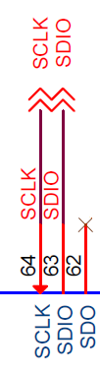

* + - * Serial Data Output; Data read when 3 wire mode
    - SDIO
      * Serial Data Input/Output; Data write when 3 wire mode, Write/Read when 2 wire mode
    - SCLK
      * Serial Programming Clock. Data clock for serial programming. This pin has an internal 50 kΩ pull-down resistor
* What I figured out
  + Our circuit doesn’t use CMOS Out (Why?, What it does?)

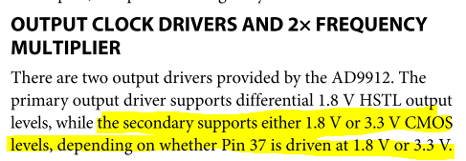

* To do
  + Study more

### 2020.01.08

* Goal
  + Understand why we need pins as such
* Progress
  + What are they?

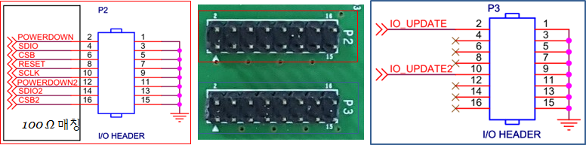

* So they are general inputs to operate normally
* Something unclear
  + How to write FTW?
* Summarized the SYSCLK PLL Doubler
  + But still I feel lost
* To do
  + Figure out how to write FTW

### 2020.01.09

* Goal
  + Figure out how to write FTW
* Progress
  + Notes from the meeting with TH. Kim
    - DDS
      * AD9910이 Amplitude modulation에 유리할 수 있음 (확인)
        + **AD9910 eval board 미리 주문**

**DDS 차후 제작**

* + - * + **AD9912 DDS bord는 제작**
      * FTW의 HEADER먼저 보내야 하며, FTW 비트 모두 사용 안 하고 address 부분만 변환하면 되는 거일 수도있음. (계산 필요)
      * Setup time and Hold time
        + Setup time: DATA bit등이 쓰여지기 전에 enable이 data bit up보다 이전에 되어야 하는 시간
        + Hold time: DATA bit이 제대로 쓰여지기 전에 enable이 up 되어 있어야 하는 시간
      * **이번 디자인에서는 OUT_CMOS를 PCB 보드 위에 달아서 살려놓자**
    - PCB 제작
      * OrCAD로 열어서 거버파일 확인해보기
      * QDrive, Eagle 사용법, Vaccum chamber -> PCB design
      * 이민제에게 적층구조 문의, 거버파일 어디서 가지고 왔는지, 적층구조는 어디서 갖고 온 건지
      * **DDS PCB 제작 담당자에게 연락**
    - Helmholtz coil
      * Dimension 관련하여 이우준 박사와 상의
  + How to write FTW
    - SDIO로 SPI 통신
* To do
  + AD9910 eval board 견적 받기
  + DDS PCB 제작 당담자에게 연락

### 2020.01.10

* Goal
  + Request quote for an AD9910 eval board
  + Contact to the DDS PCB manufacturer
* Progress
  + AD9910 eval board quote

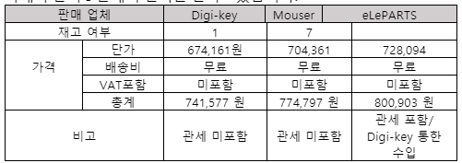

* Decided to buy the board via eLePARTS
* DDS PCB manufacturer
  + He (she?) follows the requests which had been told long ago
    - In 2019.7
  + Few more request

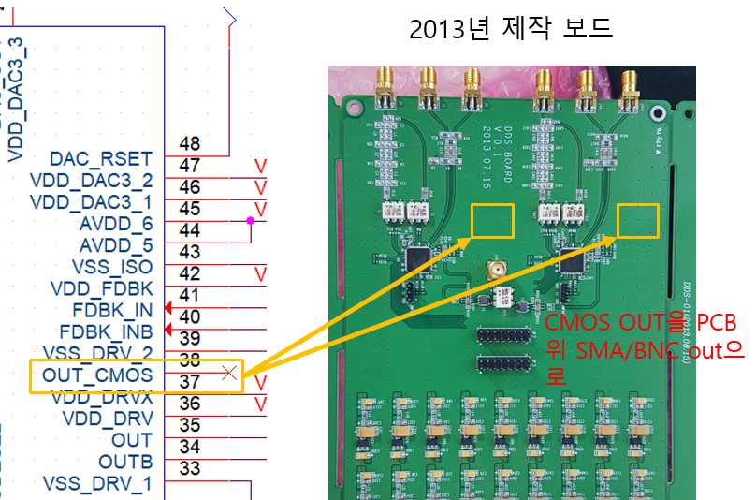

* Wait for the quotes for SMT
* To do
  + Calculate the timing of the board

### 2020.02.06

* Goal
  + Read the FPGA code and check the Artwork
* Progress
  + The Artwork 1st revision
    - EOIS sent 1st revision
    - This can be found
      * Q:\qc_user\Designs - Circuit\DDS_EOSI\200206_Artwork_1차_수정
    - Issue?

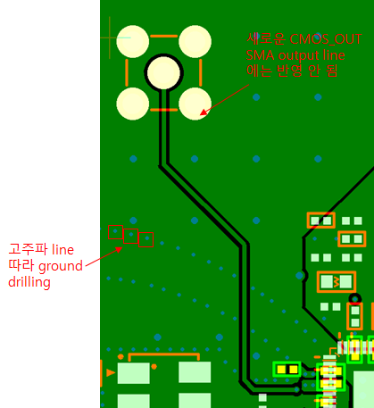

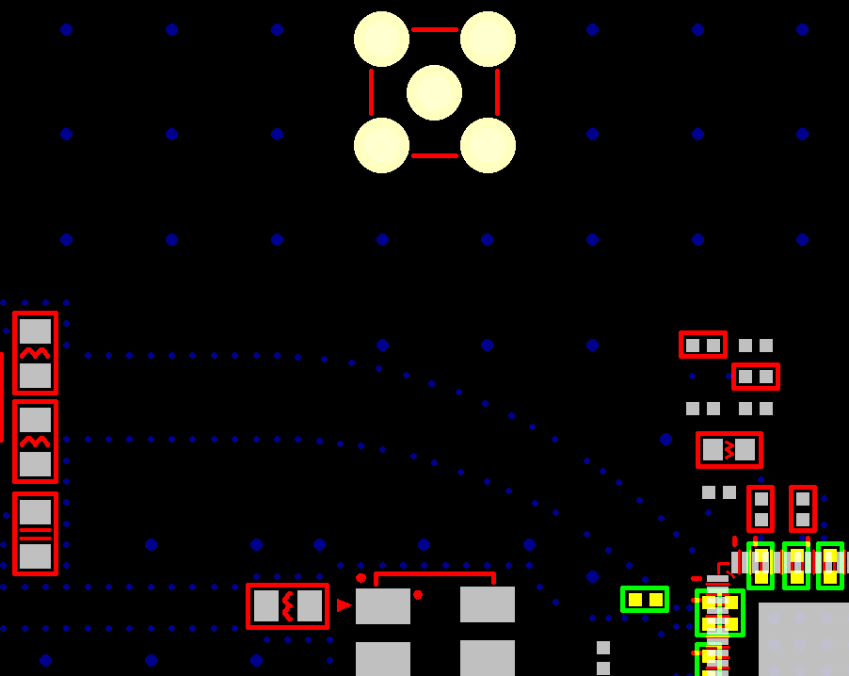

* Maybe it is fine because it is built in the inner layer???
* FPGA Code
  + It’s been awhile since I read and code FPGAs. so I got rusty
  + Today’s analysis
  + **main_with_capture_waveform_data_v1_00.sv**

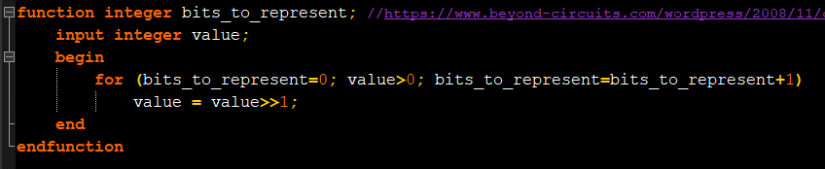

* + Let’s check what it does
    - It accepts the input “value”
    - for
      * Start: bits_to_represent=0;
      * ~~Until: value > 0;~~
      * Keep doing it while value > 0;
        + which means it stops when value ≤ 0; **so 0.**
      * Step: bits_to_represent=bits_to_represent+1;
    - “value” goes to “value >> 1”
      * “value >> 1” means

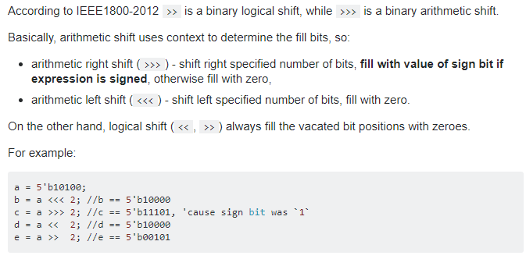

* + - * It shifts a bit to the right and fills the blank with 0. (what?)
        + ~~Doesn’t it always make the value positive?~~
        + Example

5b’01000

Need only 4 digits to represent the value

5b’11001

Need 5 digits

5b’00011

Need 2 digits

* + Systemverilog (.sv) and verilog (.v)?

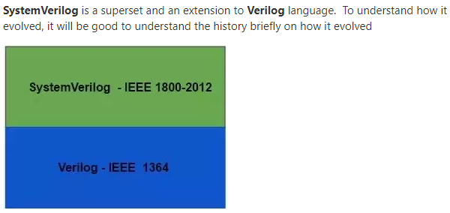

* To do
  + Read the FPGA code further and check the Artwork

### 2020.02.07

* Goal
  + Read the FPGA code more
  + Check the Artwork
* Progress
  + FPGA code
    - Loaded pre-defined data receiver

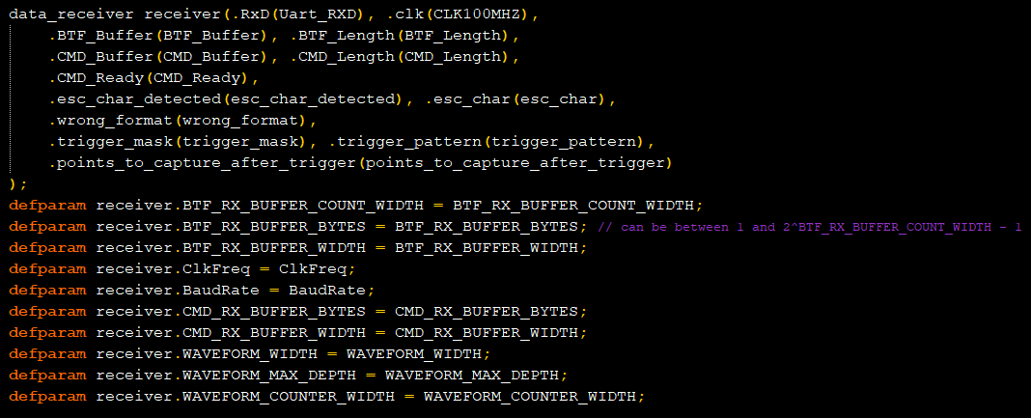

* data_reciever receiver(.Inner_parameter(outer_parameter), …)
  + Loads **data_reciever**
    - and we call it as **receiver**
    - matches the parameters from inner to outer
  + **defparam**
    - It defines inner parameters of the module

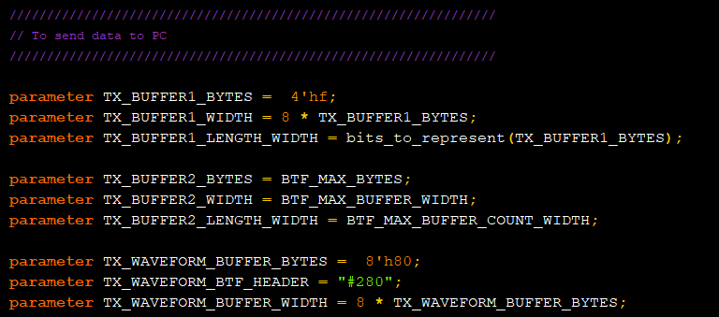

* Parameter definition for PC com
  + **parameter** TX_BUFFER1_BYTES = 4’hf;
    - f = 15
    - So the TX_BUFFER1_BYTES takes
      * 2’b1111
  + **parameter** TX_BUFFER1_WIDTH = 8 * TX_BUFFER1_BYTES;
    - * 15 * 8 = 120
  + **parameter** TX_BUFFER1_LENGTH_WIDTH = bits_to_represent (TX_BUFFER1_BYTES)
    - In the function “bits_to_represent”
      * 0, 1111 => 0111
      * 1, 0111 => 0011
      * 2, 0011 => 0001
      * 3, 0001 => 0000 (it stops here)
    - So need 3 bits?

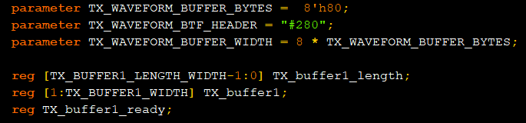

* TX_WAVEFORM_BTF_HEADER = “#280”
* Python code (DDS_V1_00.py)

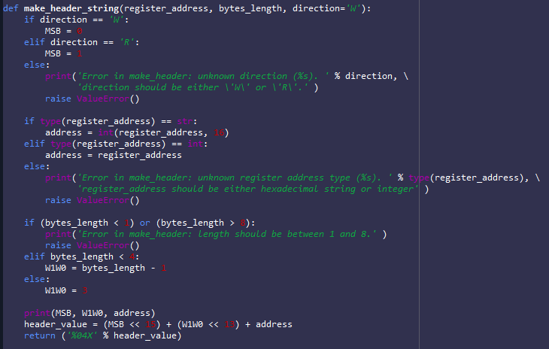

* It makes a header which has 16 bits
  + MSB indicates if it is in “write mode” or “read mode”
  + register_address:
    - if it is a string but in hexadecimal
      * int(register_address, 16)
      * means it converts hexadecimal string to int
        + int(‘10’, 16) → 16.
        + int(‘101’, 16) → 257.
  + W1W0
    - represents bytes_length
    - bytes length is between 1 and 8
    - when the length is more than 4
      * it goes to 3 (b’11)

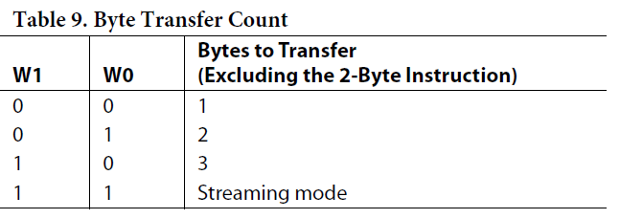

* Streaming mode
  + - * since 5 ~7 needs 3 bits to be represented in binary
  + header_value
    - MSB + W1W0 + ADDR
  + return (‘%04X’ % header_value)
    - Switches the header value to hexadecimal value with 4 characters filled with 0
    - examples

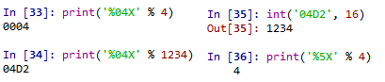

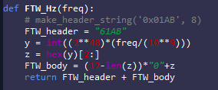

* y = int((2**48)*(freq/(10**9)))
  + 2**48 is from frequency tuning word

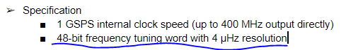

* freq/(10**9) is from
  + The maximum output freq. is 1 GHz (10**9)
  + say, we want to tune to 100 MHz
  + (10**8)/(10**9) = 0.1
* so that y = int(0.1*2**48) = int(28147497671065.6) = 28147497671065
* z = hex(y)[2:] does

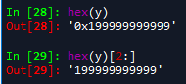

* converts y value to hexadecimal value and erase redundant values ‘0x’
* in this case len(z) = 12
  + FTW_body = (12-len(z))*”0”+z = “” + z = '199999999999'
* For 1 MHz
  + y = int((2**48)*(freq/10**9)) = int(281474976710.656) = 281474976710
  + z = hex(y)[2:] = '4189374bc6'
  + FTW_body = (12-len(z))*”0” + z = (12-10)*”0” + z = '004189374bc6'
  + return FTW_header + FTW_body = ‘61AB’ + '004189374bc6' = ‘61AB004189374bc6'
* To do
  + Understand more

### 2020.02.12

* Goal
  + Understand CMD protocol
* Progress
* Python code

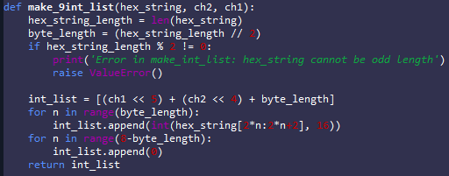

* + - make_9int_list(hex_string, ch2, ch1):

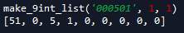

* This is based on the com protocol
  + list[0] indicates which channels are activated and its string length
    - This is a safe protocol since the byte_length cannot exceed 16
    - To do so, 32 hex characters needs. which means 16^32.
  + FPGA code

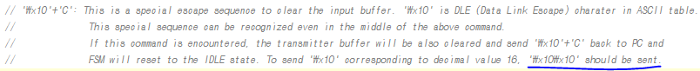

* To do
  + Read further the code

2020.02.14

* Goal
  + DDS board test
* Progress
  + ?

